**Assignment 3**

**CEE 598**

**ASU ID: 1215306430**

Q1:

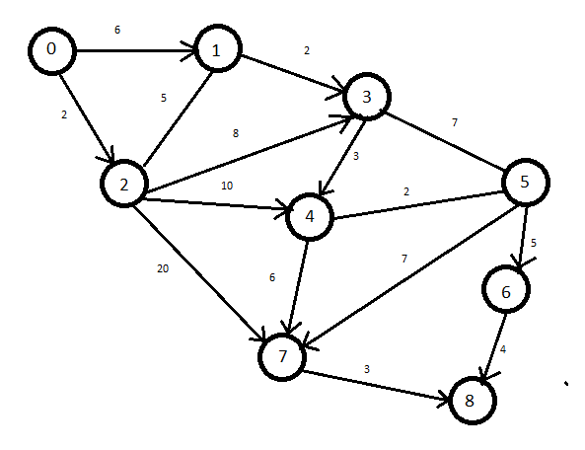

For the given network I used the Dijkstra’s Algorithm to solve it manually

The shortest path is 0-1-3-4-7-8 with the cost of 20

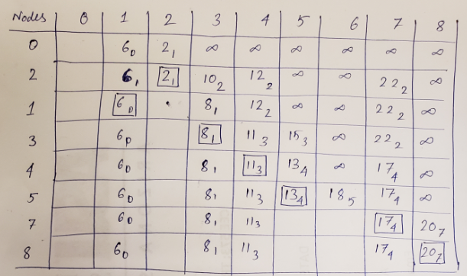

Q2:

I ran the python code of label correcting algorithm to find the shortest path for the given network.

The results are as follows:-

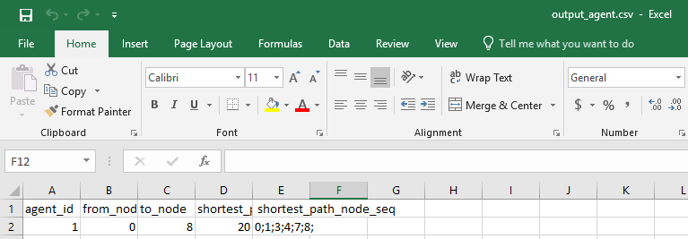

Q3:

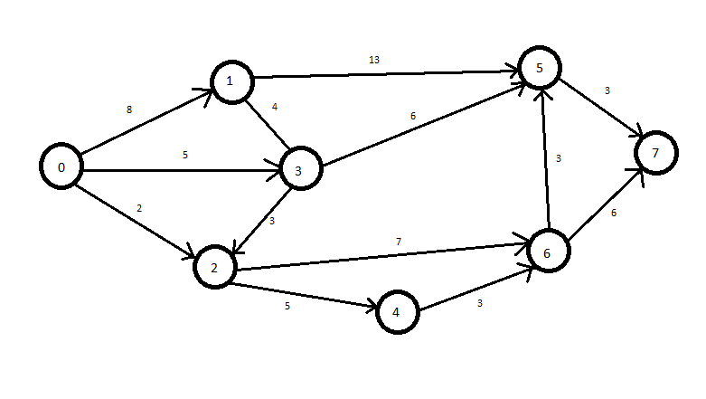

This is the network created by me. I solved it manually by using the Dijkstra’s algorithm.

The shortest path is 0-3-5-7 with the cost of 14

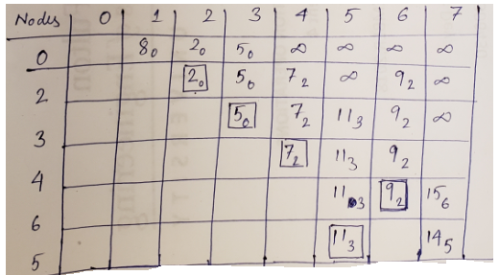

I ran the python code of label correcting algorithm to find the shortest path for this created network.

The results are as follows:-

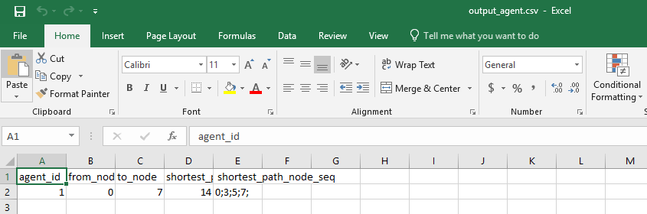

The results of the code check out with the results gotten manually.